金华市2020年初中学业水平考试
英 语 试 题
说明:本卷共有三大题， 45小题，满分70分。
第一部分 听力部分
一、听力
第一节:听小对话, 从A、B、C三个选项中选出正确的选项, 回答问题,
1. Where is David's bike?
A. At school gate. B. In front of the house. C. On the street.
2. Who is the woman in the middle of the photo?
A. Tony's sister. B. Tony's mother. C. Tony's aunt.
3. What is Jim going to do tonight?
A. To go shopping. B. To watch a movie. C. To look after his sister.
4. Why is Anna in hospital?
A. Because she has ac
B. Because she has a fever.
C. Because she has a stomachache.
5. How is Tom probably feeling now?
A. Excited. B. Sad. C. Angry.
第二节;听长对话, 从A、B、C三个选项中选出正确的选项, 回答问题。
听下面一段较长对话, 回答问题,
6. How often does Peter go swimming?
A. Every day. B. Once a week. C. Twice a week.
7. With whom does Peter usually go swimming?
A. His father. B. His brother. C. His sister.
听下面一段较长对话, 回答问题。
8. Who is calling Mike?
A. John. B Amy. C. Cindy
9. When will Mike and his classmates have the picnic?
A. On Friday. B. On Saturday. C. On Sunday
10. What does Mike need to take?
A. Snacks and drinks. B. A hat and sunglasses. C. A camera and an umbrella.
第三节:听下面一段独白, 从A、B、C三个选项中选出正确的选项, 回答问题。
11. Who is Lucy most probably speaking to __________.
A. Students. B. Teachers. C. Parents.
12. What books can be found on the second floor?
A. Books about English. B. Books about science. C. Books about history.
13. How long can you keep the books from the library ____________.
A. One week. B. Two weeks. C. Three weeks.
14. When does the library close on weekdays?
C. At 6:00 p.m. B. At 5:00 p.m. A. At 4:00 p.m.
15. Where can you get a library card?
A. In Miss Lee's office. B. In Lucy's office. C. In Linda's office
第二部分 笔试部分
二、完形填空
阅读下面短文, 掌握其大意, 然后从每题所给的A、B、C、D四个选项中选出最佳选项.
Sam was very nervous. It was his first day in new ___1___, and lunch was only thirty minutes away. For most students, lunch is the ___2___ part of the school day. It is time when you talk with your friends, get to know what interesting things everyone is doing, and, of course, ___3___. Sam, however, didn’t know anyone or anything, like where to sit or with whom to sit at lunch.
Sam’s ___4___ was in the army. so his family moved a lot. He had really liked his old school and ___5___ leaving his two best friends. They still talked to each other through phone calls and emails, ___6___ he couldn’t see them every day. He wondered if their ___7___ would continue. He didn’t want to lose them, but he knew it would be ___8___ for them to stay close.
“I know this is hard on you,” his mother said as he got ready for school this morning, “and I’m really ___9___ you have to keep changing schools.” Sam could see regret in her eyes, but he didn’t want her to feel that way. ____10____ had always been ready to defend(保卫) not only the family but also the country. Sam loved her so much. He gave her a smile and told her not to _____11_____. He had wanted to mean it, but there was still always worry in him when they moved.
The ____12____ time came quickly. As Sam was walking to the dining room a voice behind him said. “Excuse me.” Sam ____13____ and saw five friendly faces.
“Would you like to join us?” asked one of them.
This ____14____ invitation was exactly what he needed. Sam nodded yes ____15____ and joined them. He was sure about his future school life now.
1. A. company B. family C. factory D. school
2. A. best B. longest C. shortest D. worst
3. A. eat B. learn C. run D. sleep
4. A. brother B. father C. mother D. sister
5. A. hated B. imagined C. tried D. suggested
6. A. so B. or C. but D. if
7. A. discussion B. dream C. business D. friendship
8. A. safe B. hard C. natural D. terrible
9. A. proud B. sorry C. excited D. surprised
10. A. He B. I C. She D. We
11. A. forget B. move C. return D. worry
12. A. breakfast B. lunch C. tea D. dinner
13. A. sat down B. got up C. ran away D. turned around
14. A. unexpected B. creative C. funny D. popular
15. A. bravely B. happily C. nervously D. patiently
三、阅读理解
阅读下列材料. 从每题所给的A、B、C、D四个选项中选出最佳选项。
A
Basketball, running and swimming are popular events(项目）at the Olympics. But there are also some events that are not as popular. Some are even very strange. Let's see if you have any knowledge about the following events.
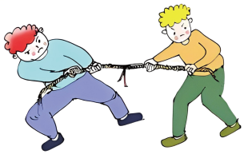 | Tug-of-war  This event started in 1900 and left the Olympics in 1920. The team wins if they pull the rope past a certain point first. Interestingly, more than one team from a country can enter in this event. This makes it possible for one country to win several medals.
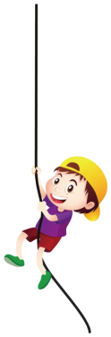 | Rope climbing  It first appeared as an Olympic sport in 1896. The climber who spends the shortest time reaching the top is the winner. The rope used to be 15 meters long. Years later, it was shortened to 8 meters for some reason. After 1932, there was no rope climbing in the Olympics.
 | Race walking  In race walking, walkers have to win the race by walking. To make sure that they do not run, race walkers must have one foot on the ground at all times. Race walking has been an Olympic sport since 1904. Men enter in 20 kilometer and 50 kilometer races; women only race 20 kilometers.

16. Which of the following events left the Olympics in 1920?
A. Rope climbing. B. Basketball.
C. Tug-of-war D. Race walking.
17. The rope in rope climbing was _____________metres long in 1896.
A. 8 B. 15 C. 20 D. 50
18. Which of the following is TRUE according to the passage?
A. One country can only enter one team in tug-of-war.
B. Rope climbing first appeared in the 1932 Olympics.
C. Women in race walking can enter in the 50 kilometer race.
D. Race walking is still an event at the Olympic Games today.
B
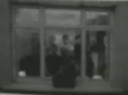
Every night, just after the sun goes down. Ruth Medjber talks with her neighbours in Dublin, Ireland, and takes a picture of them at their windows.
These photos, in some way, show people's lives during the global pandemic (大流行病).
"I started out taking photos of just friends and family. In this way I could connect with them during this special time when people have to stay at home," the photographer explained. "I live alone, so I was missing the days when we were free to communicate with friends. Every evening, on my way to seeing friends, I had a sense of purpose."
Now she's making new friends.
The photo project has taken off online, and she has opened it up to volunteers. But they must be the people who live within 5 kilometers of her home—the Irish government doesn't allow people to go farther out than that.
"I pick a street each night and try to take photos of volunteers," Ruth said. "I usually take about four photos before it is completely dark, but two if I'm talking a lot—which I love to do."
She said more and more neighbours are joining in her photo project and it has now got a name, Low at Home.
"I think people like knowing that they're not alone even if they have to stay at home, and they really try to pick out those who are similar to themselves in the photos," she said. "It's also a different view(视角) of the pandemic: the more human view. Instead of showing what the pandemic has taken from us, it shows that it has given us more chances to be with family and friends and spend time together."
"I think we'd love most to find something nice, even in the most serious situation as it is now," Ruth said.
19. Ruth started out taking the photos in order to____________.
A. raise some money B. connect with friends and family
C. make new friends D. join in a photo project of volunteers
20. According to the passage, Low at Home is the name of ____________.
A. a photo project B. the picture shown in this passage
C. a street in Dublin D. the special time when people stay home
21. According to what Ruth said in Paragraph 8, "the more human view" shows____________.
A. the beauty of streets in a city of Ireland
B. how people do things when staying at home
C. the moment of family and friends being together
D. what the global pandemic has taken from people
22. From the passage we can infer(推断）that Ruth is a _____________ person
A. careful B. shy C. hardworking D. loving
C
My dear boys and girls, good morning. Today I'm going to talk to you, about my understanding of learning history.
Many of you may think it is a terrible thing to study history. You may often wonder why we students should study something that has nothing to do with our own lives. If you think that way I should say you are far from the truth.
In fact, if we study history, we can learn quite a lot about personal stories and events (事件)of people just like us. The people who came before us helped build and develop the country we are living in. Their ideas often solved many of our problems and troubles. Studying the past helps us to understand what our ancestors'(祖先)lives were like. And it also helps us to see how their experiences have shaped our own life.
To be honest, ▲ . Some of what we study in history helps us understand the mistakes of the past. And these mistakes will help people not to do the same wrong things. People often learn from the past to have a better future.
Whether we like the subject of history or not, we must understand the importance of the events and the people who came before us. Our ancestors' decisions have influenced our own life. Similarly, the decisions of our own generation(一代人）will finally influence those who come after us. In this only way, the world is truly connected.
History is not just a study of the past. History is the study of people, places, and events that can influence the future.
Now do you still think studying history is a sad thing? Or do you have any doubt about learning history? If you have any question, just feel free to ask.
23. What kind of writing is the passage above?
A. A diary. B. A story. C. A speech. D. A letter.
24. Which of the following can be put in the ▲ in Paragraph 4?
A. the mistakes of the past won't help us.
B. I don't like the idea of learning history
C. it is not easy to learn the subject of history
D. not everything that happened in the past is good
25. According to Paragraph 5, the decisions of our generation will ______________.
A. show what is happening to us B. build and develop our country
C. influence the people in the future D. help understand the people in the past
26. The writer wrote the passage to ___________________.
A. introduce some important people in history
B. develop students' interest in learning history
C. explain different people's understanding of history
D. show the relationship between the past and the future
D
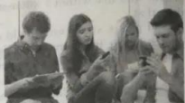
Very often, when we see young people sitting there, looking at the screen of a mobile phone and smiling, we may think nothing is wrong. But when we come to the question "how much time do they actually spend on media(传播媒介）daily?", the answer is surprising: young people spend about nine hours every day using media, and this only includes media used for enjoyment.
Today's young people seem to have become crazy multitaskers. They often use media when doing other activities. Some watch TV when doing homework, some text(发短信), and some others listen to music. But what do young people think of this? A research showed that two thirds of them believed watching TV or texting had no influence on their schoolwork. Half of them thought using social media made no difference. However, researches have given a different answer: "media multitaskers" did worse in tests.
Scientists did a research among more than 400 students. It shows that those who text a lot have more trouble sleeping and do worse in their study. In another research, students who didn't text during a lesson took down a lot more notes than those who were texting. A similar research also found that students who texted when doing schoolwork had lower overall(总体的）grades.
According to a research, if a kid uses social media a lot, especially at night, he or she will sleep worse and feel more nervous and depressed(消沉). On the one hand, young people stay up late to check messages and information. They may also be woken up by messages they receive. On the other hand, even the light from a screen could influence their sleep. Some other researches also show that children who use media at night go to bed later, get fewer hours of sleep each week, and become sleepy more easily during the daytime.
27. The answer to the question in Paragraph l is surprising because young people ______.
A. spend about 9 hours on media for fun daily
B. often look at their mobile phones and smile
C. always sit there for a long time doing nothing
D. use different kinds of media to relax themselves
28. The underlined word "multitaskers" in Paragraph 2 refers to people who___________.
A. ask a lot of questions B. use different media for learning
C. have several mobile phones D. do several tasks at the same time
29. From the passage we can learn that a kid will probably ________ if he or she uses social media a lot at night.
A. become more worried B. get more excited
C. take fewer notes in class D. sleep much better
30. What is the passage mainly about?
A. Social media is very popular among young people.
B. Using media too much has a bad influence on young people.
C. The use of social media has both advantages and disadvantages.
D. Mobile phones are the main tools students use for school learning.
第二卷
说明:本卷共有四大题, 31小题, 满分50分。
四、词汇运用
A. 用方框中所给词语的适当形式填空。每词限用一次。
attend beside season sudden take pride in

31. Among the four __________ of year, I like winter best.
32. Usually, parents ___________ the smallest success of their children.
33. We ____________ realized that everything seemed to have changed in one night.
34. Sally is my best friend. She always sits _____________ me silently when I am sad.
35. Everyone likes to __________ Mr. Smith's classes. They are always interesting and lively.
B. 阅读下面短文, 然后根据括号内所给汉语意思写出单词的正确形式。每空限填一词。
Singapore is a city of different cultures. Waking through the streets of Singapore, you can ___36___ (听到)different languages spoken, such as English, Chinese and Malay. People from different cultures live and work peacefully with each other and___37___ (分享）their traditions.
In Singapore, cultural differences are shown in building, styles, shops and in many other ways. Take food as an ___38___(例子), each culture has its own place to sell their traditional food, but there are also the ___39___ (著名的) Hawkers Markets. Different foods are sold here in these ___40___ (繁华的) markets. And there very popular with Singapore citizens and ___41___ (游客)from around the world. The food is good and very ___42___(便宜).
Singapore is also an interesting city. Large number of people, ideas, etc, are mixed together ___43___(在……下面) the same sky. English is used for business, ___44___ (虽然）the official language here is Malay. Now, however, there is a strong Chinese business community and also a growing Indian business community. Singapore welcomes talented people from around the world and ____45____(希望）they will live there all their lives.
五、语法填空
Last week, he ___46___(come) to visit us in Canada. But he was very disappointed when he found nobody here could play chess with ___47___ (he).
One day, when I came back from school, I found my grandpa was sitting ___48___(quiet) in a chair, doing nothing. I knew he was lonely. Why not teach him to play online chess on my computer? I thought.
"Grandpa, someone is waiting ___49___ you to play chess." I went to him and said.
"Really?" he said, his eyes opening wide. "Who? And where?
I took him to ___50___ computer in my room and said, "Right here." Then I taught him how to use the Internet and how ___51___ (play) chess online. At first, he was slow. Having tried several times, he became better and began to play chess with people from around the world.
"___52___ interesting it is! This is simply fantastic!" he cried excitedly.
Now he is quite good at playing chess online and has made a lot of ___53___ (friend) on the Internet at the same time. My grandfather is much ___54___ (happy)than before.
Grandpa will go back home soon. I believe the time when we played online chess together was so great ____55____ both of us will never forget.
六、任务型阅读
阅读下面短文, 根据所给信息, 完成组织结构图, 每空不得超过三个词。
Good readers often use a flowchart（流程图）or webs(网状图）to have better picture of what they read (see the drawing on the right).
A flowchart is used to put events in a certain order. Webs show a main idea and supporting details(细节).
Now try to be a good reader and finish the following TWO tasks.
Task 1: Read Passage l and complete the flowchart.

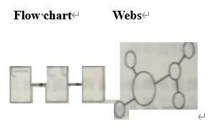

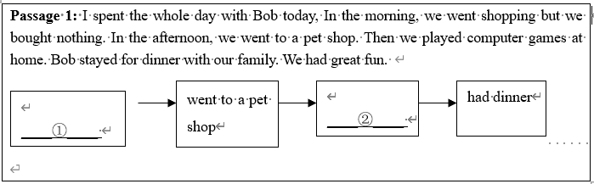
Task 2: Read Passage2 and complete the webs.
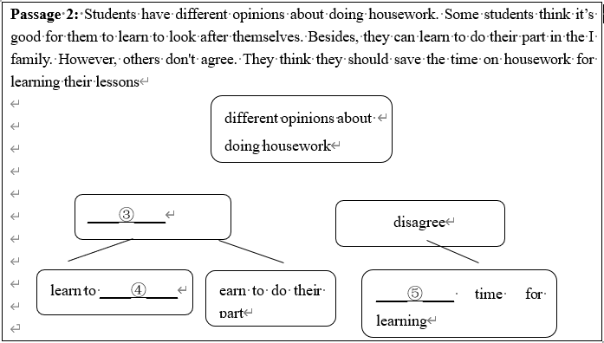

56. ①________
57. ②________
58. ③________
59. ④________
60. ⑤________
七、书面表达
61. 假如你是李明，某英语网站正在举办以“感恩父母”为主题的征文活动。请根据表格中的内容，写一篇题为“A Letter to My Parents”的短文，用于投稿。
注意：1. 文中必须包含三个方面的内容要点，可适当发挥；参考词汇供选择使用；
2. 文中不得出现真实姓名、学校等信息；
3. 词数:80～100；
4. 文章的开头与结尾已给出，不计入总词数。
内容要点 | 参考词汇
Parents’ care | cook food, take…to and from school, look after…
Parents’ love | trust, advise, encourage…
My thanks | …

A Letter to My Parents
Dear Mum and Dad.
___________________________________________________________________________________________________________________________________________________________________________________________________________________________________________________________________________________________________________________________________________________________________________________________________________
Love from
Li Ming

