2022年浙江省初中毕业生学业水平考试（嘉兴卷）
英 语 试题卷
考生须知:
1.本试题卷分卷一（选择题）和卷二(非选择题）两部分。请考生使用规定用笔，将所有试题的答案涂、写在答题纸上。做在试题卷上无效。
2.全卷共8页，6大题。满分为90分。考试时间为100分钟。温馨提示：答题前请任细阅读答题纸上的“注意事项”。
卷一
说明:本卷共有两大题，30小题，满分45分。
说明:本卷共有两大题，30小题，满分45分。
一、完形填空(本题有15小题，每小题1分，共计15分)
阅读下面短文，然后从各题所给的A、B、C、D四个选项中选出一个最佳答案。
The first time, Hank, a two-year-old cat, went out of his yard, he got stuck in a 40-foot-tall tree for five days, with no food or water.
One day last November, when Delores, the ____1____ , returned from a market, she found Hank didn’t come in for his lunch. As it got ____2____ , she began to look for him around the house. Then she heard the mew of a cat, ____3____ , and saw Hank on her neighbor’s tree. He must have climbed onto the tree while some dogs were running after ____4____ , and became too afraid to climb down.
Delores, now very ____5____ , called the firemen immediately. But it was not easy, so they didn’t have a ladder（梯子） tall enough to ____6____ the cat. She asked a tree company for help them. ____7____ they failed for safety reasons.
The poor owner could do nothing but sit ____8____ the tree and call to Hank. A kind neighbor offered her some cat food, ____9____ it would make the hungry cat come down. Nearby dog owners took their pets for _____10_____ instead of letting them out in their yards, so that Hank would not climb even _____11_____ with fear.
Nothing had worked until it came to day five. _____12_____ Lyda, another neighbor, talked of a clever way of getting the cat down from a tree, Delores decided to _____13_____ it at once. Together, they produced a system of pulleys（滑轮） and lifted a _____14_____ with some of Hank’s favorite things up to him. To their excitement, Hank jumped into it.
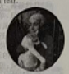

Delores was really thankful. “I feel good living in such a _____15_____ neighborhood. It gave me hope when Hank was in trouble,” she said.
1. A. owner B. visitor C. sister D. neighbor
2. A. cold B. dark C. quiet D. dirty
3. A. ran away B. turned back C. fell down D. looked up
4. A. it B. her C. him D. them
5. A. tired B. worried C. surprised D. relaxed
6. A. feed B. train C. reach D. watch
7. A. Again B. Instead C. Besides D. Anyway
8. A. across B. behind C. under D. opposite
9. A. expecting B. promising C. realizing D. regretting
10. A. help B. sale C. baths D. walks
11. A. better B. slower C. higher D. harder
12. A. If B. When C. Since D. Before
13. A. try B. find C. repair D. change
14. A. toy B. fish C. rope D. basket
15. A. peaceful B. friendly C. popular D. wealthy
二、阅读理解(本题有15小题，每小题2分，共计30分)
阅读下面四篇材料，然后从各题所给的四个选项中选出一个最佳答案。
A
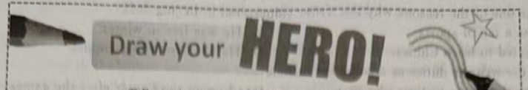
Tell us who inspires you — and then draw.
And we are giving away prizes worth more than $125 to 11 winners!
Heroes can be different but they all have one thing in common. They inspire us to do better. They could be a creative artist or dancer, a wise scientist or a skillful sports star. And heroes don’t have to be famous. They could be someone like a parent, brother, friend or teacher, who quietly goes about making the world a better place.
Whether your hero is known around the world, or is someone closer to home who simply makes you laugh or is kind to you, we can’t wait to see your drawings of them and read about who inspires you! See below for instructions on how to enter the competition. Good luck!

Download and print out templates (模板) to draw your picture on by visiting http://kidspic.com.au. On the blank postcard template, draw a picture of your hero. On the line in the center,tell us who your hero is and how you are inspired.
The competition is open to 1-3 graders. You can ask your parent to take a photo of your drawing and email it to us at competition@kidspic.com.au. Please send in only ONE picture,and note that it closes on 22 June.

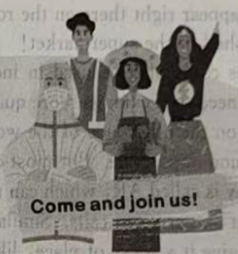
Each winner will receive a fantastic prize worth more than $125, including:
a box of 24-colored pencils
a cool desk set
a set of comic books
a fine basketball

16. What do heroes have in common according to the poster?
A. They are clever. B. They are brave.
C. They are famous. D. They are inspiring.
17. What should you do before drawing if you want to enter the competition?
A. Print out the templates. B. Take a photo with your hero.
C. Send in one or two pictures. D. Buy a box of 24-colored pencils.
18. Who might be most interested in the poster?
A A cartoon artist. B. A computer scientist.
C. A second-year pupil. D. A fifth-grade teacher.
B
My Olympic volunteering journey started last September. I was excited as I was myself a sports fan and my home country has not hosted a competition like this. It was a great chance for me to both watch and serve the Olympics.
After getting trained through the Internet and spending two weeks in quarantine (隔离), I began to volunteer inside the Wukesong Sports Center. The Center hosted ice hockey games for both men’s and women’s teams. My job was to guide the audience (观众) to their seats and answer their questions. I was wild with joy to be present and watch my first-ever Olympic games live, on the ice. All the games were interesting, and I watched them whenever my volunteering duties would allow.
In our free time, we had pleasant conversations. It was the best chance for us foreign students to learn more about the Chinese New Year celebrations, and this year, to celebrate it together with our Chinese friends. It was really a big festival. We had special Chinese dishes like dumplings, fish and spring rolls. I also tried to write Chinese characters.
I decided to make the most of the chance and introduce my African and Rwandan customs to other volunteers. I showed to them the real Africa that they had never seen on TV before. From geography to social life I made them understand more about Africa by giving examples of my hometown. It was a great platform (平台) for us young people to share both our cultures and futures.
As an international volunteer for Beijing 2022, I was given a special experience to help others and more importantly, to learn about the spirit of the Winter Olympic Games. I’ll never forget it.
19. Which was one of the reasons why the writer volunteered in Beijing 2022?
A. He was a fan of sports. B. He was free in winter.
C. He wanted to learn Chinese. D. He likes travelling around.
20. What did the writer’s duties as a volunteer include?
A. Guiding the teams to their places. B. Cleaning the Center after the games.
C. Giving out food and water to the players. D. Answering questions from the audience.
21. What does the underlined word “it” refer to in Paragraph 4?
A. The Chinese Spring Festival. B. The Beijing Winter Olympics.
C. The Wukesong Sports Centre. D. The Foreign Students’ Organization.
22. Why does the writer write the passage?
A. To share his Olympic volunteering experiences.
B. To express the strong love for his home country.
C. To show the spirit of the Winter Olympic Games.
D. To spread African cultures to the rest of the world.
C
Smartphones are getting boring. The new models are either a bit faster or have better cameras, but they are basically no different from the ones already in our pockets. This is why scientists are hoping, and working for something new, something that will change our lives just as greatly as smartphones do. At the moment, the next invention might be smart glasses.
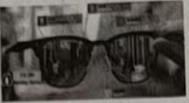
Just imagine. Instead of having to pick up your phone and look at the screen, all of the information you need simply appears just in front of you, in your glasses. Satellite navigation (导航) directions would appear right there on the road. And your smart glasses could guide you to the right shelf in the supermarket!
Smart glasses could also be used in industry. They could show engineers the instructions they need to fix things more quickly. A doctor could carry out a difficult operation, guided in real time by someone on the other side of the world.
This may sounds impossible. But most of the technologies to invent them are already there. For example, one key technology is called AR, which can make digital 3D objects appear as if they are part of the real world. We’ve used it a lot on our video calls. Similarly, huge progress has been made in spatial audio. This is when a sound is made to give it a sense of place, like what you hear in an empty room. Some high-end earphones can already do that. Future glasses will of course need to recognize (识别) your voice to do tasks. This technology has been widely used in our daily life.
So, why aren’t we all wearing smart glasses yet? So far, no one has invented a good way to send images (映像) of our world onto glasses. However, with the rapid development of technology, smart glasses could arrive much sooner than we think.
23. Why does the writer mention smartphones in Paragraph 1?
A. To start a story. B. To explain an idea.
C. To introduce a topic. D. To discuss a problem.
24. What are Paragraphs 2 and 3 mainly about?
A When smart glasses might be made.
B. Where smart glasses could be used.
C. How smart glasses would give directions.
D. Why smart glasses should be changed.
25. Which of the following technologies needs to be improved to invent smart glasses?
A. Making spatial audio. B. Recognizing voices.
C. Creating digital 3D objects. D. Sending images onto glasses.
26. How might the writer feel about the future of smart glasses?
A. Bored. B. Confident. C. Satisfied. D. Uncertain.
D
When Leon Martin asked for his parents’ advice on how to become a UX designer (设计师), they both went silent. “In fact, I had no idea what he was talking about,” said Anne, his mother. “I don’t know whether he was talking about designing clothes, computer programs or a fancy brand of bike.”
Even when her 18-year-old son explained that it was something about “behind the scenes” online design, his mother was still a bit lost. “I felt like I had totally failed as a parent,” she said. “My job as a parent is to open doors so my children can achieve their potential (潜力), but now can I do that when I don’t even understand what their dreams are?”
_________ Research has found that more than 2/3 of parents in England are now facing the problem that, when their children express interest in new education and job choices, they may know nothing about them. More than 75% of parents feel it is almost impossible to offer their children good advice in such a fast-changing job market.
Michelle Rea did a survey of over 2,000 parents of secondary school students in England. She found that many parents were afraid their children hardly follow them. “We all know that parents’ opinions and suggestions play an important role in shaping and influencing their children’s career dreams,” she said. “But we usually depend much on our own experiences. And things have changed so much since most of us were at school.”
Bryony Mathew writer of the Awesome Career Books, said the world was changing so rapidly that parents should not try to decide on certain careers for their children.
27. What should a successful parent be able to do according to Anne?
A. Become a great UX designer. B. Do an excellent job online.
C. Develop their children’s potential. D. Realize their children’s dreams.
28. Which of the following is the best sentence to fill in the blank in Paragraph 3?
A. Anne is not alone. B. Anne has bad luck.
C. This is very strange. D. This is very interesting.
29. What did Michelle Rea’s survey mainly show?
A. Most of the parents in England were facing trouble in accepting new jobs.
B. Parents feared that their children would refuse to share their career dreams.
C. A lot of parents found it difficult to help their children with their education.
D. Children’s career future depend a lot on their parents’ working experiences.
30. What could be the best title for the passage?
A. How can children make career choices?
B. How can parents become career advisers?
C. Should children take their parents’ career advice?
D. Should parents choose a career for their children?
卷二
说明:本卷共有四大题，30小题，满分45分。
三、词汇运用（本题有15小题，每小题1分，共计15 分）
用方框中所给单词的适当形式填空，每词仅用一次。
above nearly relative review smooth

31. Isn’t it a pleasure to study and ______ what you have learnt?
32. It’s a tradition for us Chinese to visit our ______ and friends often.
33. Nowadays electric cars give us a much _______ ride than earlier ones.
34. Colorful balloons were hanging high _______ the square to celebrate Children’s Day.
35. Wang Yaping gave a science lesson from space to _______ 1,500 students from five classrooms across China on March 23, 2022.
阅读下面短文，然后根据括号内所给汉语意思写出单词的正确形式（每空一词)。
Most kids love sweets. Why? When we eat or ___36___ (喝) sweet food, the sugar enters our blood and influences our brain. It ___37___ (留下) good feelings with us, making us want more. In fact, all ___38___ (美味的) foods do this, but sugar has an especially strong power. That’s why doctors ___39___ (总是) advise us to cut down on sugar.
Early humans often had very little food, so our ___40___ (身体) learned to store a lot of sugar as fat. In this way, we ___41___ (节省) energy for when there was no food. But today, most people have more than enough. So it may now be harming our ___42___ (健康).
It’s certain that we need to eat ____43____ (更少的) sugar. The trouble is that, in today’s world, our foods are filled with sugar. Although our ____44____ (餐) look better, large amounts of sugar are often added. To solve the problem, we should take more exercise, ___45___ (两次) a week at least. And remember, next time you want some cookies, eat an apple instead.
四、语法填空（本题有10小题,每小题1分，共计10分)
阅读下面短文，在空白处填入一个适当的词，或填入括号中所给单词的正确形式。
My pen friend is Allison. She is a lovely Australian girl ___46___ big blue eyes. Like me, Allison loves singing and dancing, ___47___ we both like travelling to different places for our holidays.
Do you want to know ___48___ our friendship started? By travelling! Three years ago, I paid a visit to my ____49____ (uncle) home in Sydney. One Saturday my cousin and I went to the Blue Mountains Scenic World and I ___50___ (meet) Allison on the bus. She was sitting just next to me. At first, we were both a bit shy. We sat ___51___ (silent) all the way until we got near the foot of mountains. I was surprised by the amazing views and opened the window ___52___ (take) photos. That’s when Allison turned to ___53___ (I) and said, “It’s beautiful, isn’t it?” Then she began to explain why the mountains looked blue.
For the rest of the day, ___54___ three of us travelled together. We saw many koalas and were happy to see that they ____55____ (protect) well in the forest. What a great experience! Back home, I started writing to Allison and we’ve been friends ever since.
五、任务型阅读（本题有两小节;第一节有3小题,每小题1分，共计3分；第二节有1小题，共计2分)
阅读以下网页内容，然后从下面方框中所给的A,B,C,D四个选项中选出符合各部分信息的问句（其中一项为多余选项）。
How to Write like Shakespeare
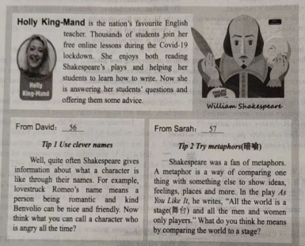
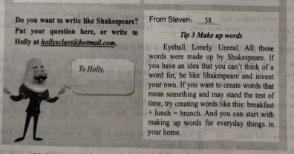
A.What’s a quick way to understand the characters?
B.How can I express my ideas and feelings in a lively way?
C.What’s the first thing I have to do if I want to write a play?
D.What should I do if I can’t find a proper word to describe something?
56. ______
57. ______
58 ______
59. Which of Holly’s tips is the most helpful to you? Why?
________________________________________________________________
六、书面表达（本题有1小题,共计15分)
60. 假如你是李华，为营造更好的校园英语氛围，你班决定以学校花园为载体，开展“Create Our Outdoor Classroom”项目式学习（COOC Project），经过分组讨论，你们形成了Plan A与Plan B 两个实施方案（见下表）。请你选择其中一个方案，用英语写一篇短文，代表小组在英语拓展课上就你们所选方案的内容和优势进行回报。
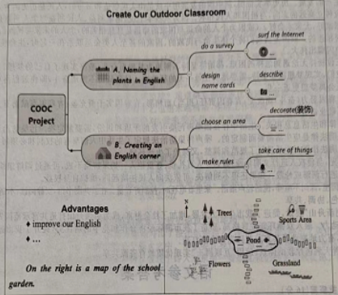
注意：(1)短文必须包含表中你所选方案的所有信息，并适当发挥。
(2)文中不得出现与你身份相关的信息。
(3)词数：80~100。短文开头已给出，不计入总词数。
Dear classmates,
I’m very proud to share our plan with you today. The plan we choose is ________________________________________________________________________________________________________________________________________________________________________________________________________________________________________________________________________________________________________________________________________________________________________________________________________________________________________________________________________________________________________________________________________________________________________________________________________________________________________________________
That’s all. Thank you!

